Kansas Barber Practical Examination Procedures – 2 Hours
TAPER MODEL Must be a live model with a minimum of ½” of hair at the nape and 2+” inches on top and 1 day of beard growth prior to beginning examination

1. Shave.
2. Facial Massage - Effleurage (eye orbits), Petrissage (cheeks), Tapotement (chin/jaw area)
3. Taper Cut.
CALL CHECK.

4. Scalp Manipulations.
5. Shampoo & Style.
CALL CHECK.
SHEAR CUT MODEL / MANNEQUIN Must have at minimum 4” of hair at the nape AFTER the haircut is finished. Allow sufficient length to perform remaining services.
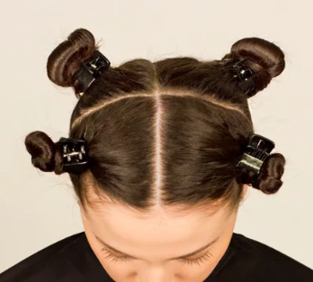
4
3
- Shear Cut.
CALL CHECK.

- Section hair into four (4) subsections - from center front to center of nape and from behind the ears over the apex of the head. See image for example.
2
Four Sections of The Hair
1

- Perform the following procedures in their designated sections. (See diagram)
Section 1 (front left) – Conventional Wrap – Four (4) perm rods.
Section 3 (back right) –Wrap of your choice (spiral, piggyback, or bricklay) Four (4) sections.

Chemical mixtures will be simulated using conditioner or similar consistency product as “color” and water as “developer”.
NOTE: BEFORE COMBINING mixtures, call for an examiner to check the ratio before you begin application.

- Perform the following procedures in their designated sections. (See diagram)
Section 2 (front right) – Highlights (1:1 - color: developer) – Four (4) sections with foils. (each must span entire width of the subsection)
Section 4 (back left) – Retouch 2” new growth (2:1 - color: developer)
starting at nape– Four (4) sections (each must span entire width of the subsection)

CALL CHECK.

